**中文版**

**“计划生育妊娠登记与生育假”网上办理指南**

**一、在线申请路径**

**（一）“交我办-后勤-业务办理-计划生育妊娠登记 / 生育假(流产假)开具申请”**

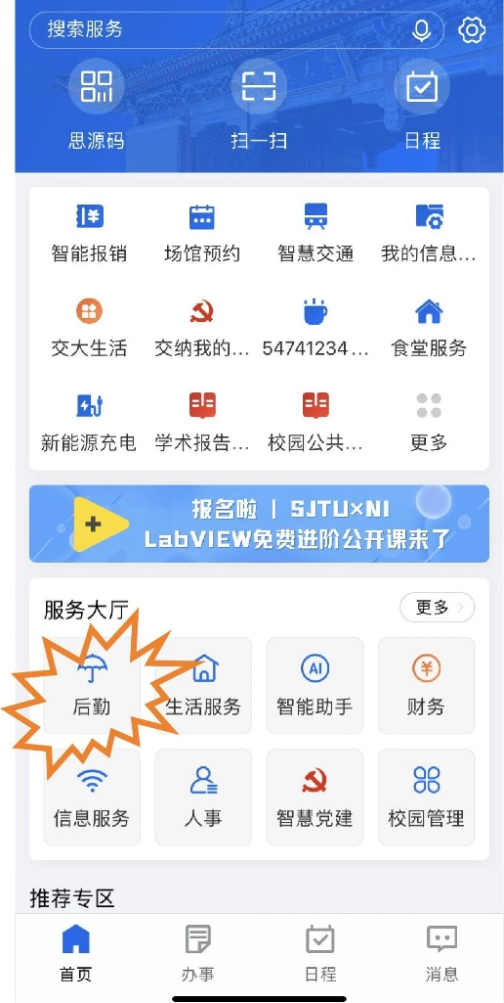 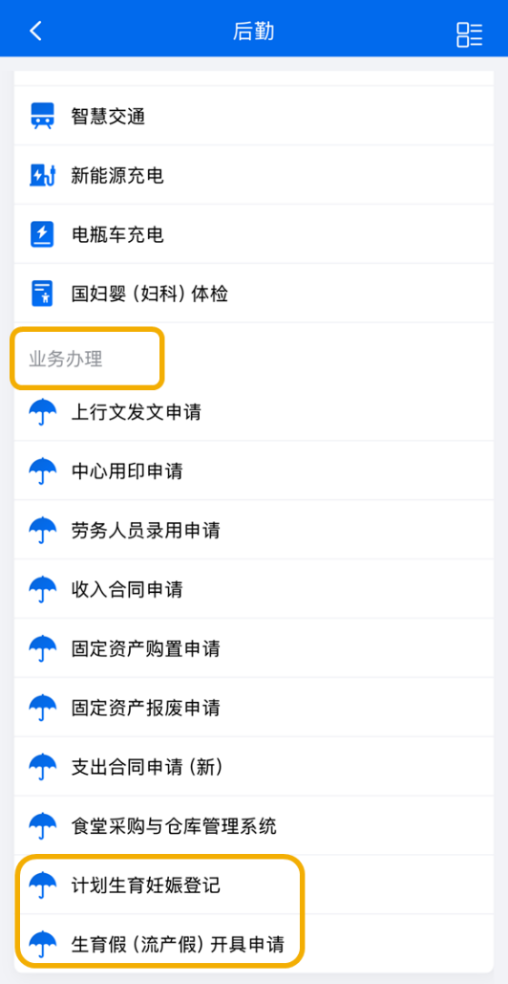

**或**

**（二） “交我办-人事-其他-生育假(流产假)开具申请”模块申请。**

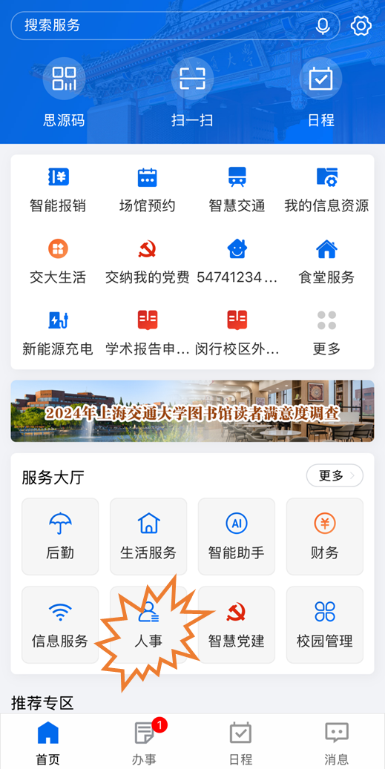 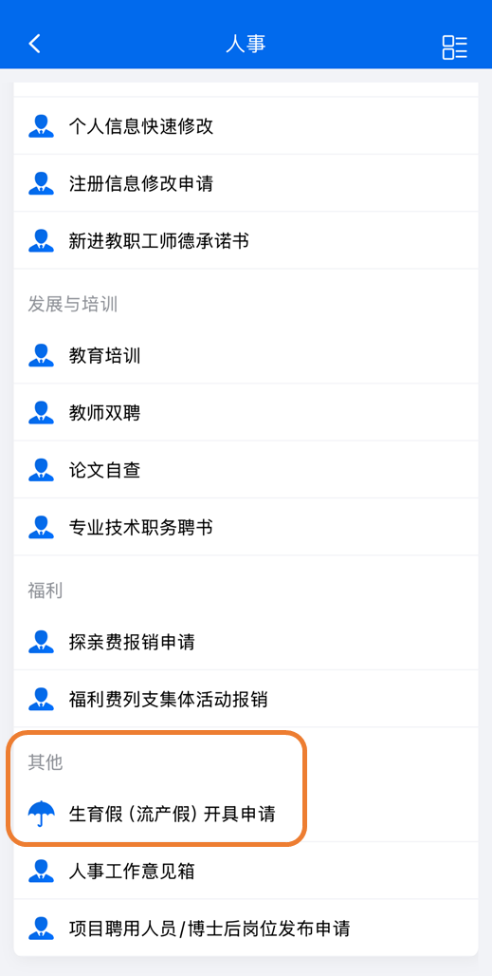

**二、流程详情**

**（一）女教工及女学生计划生育妊娠登记**

**01｜本人提交相关材料**

**02｜二级单位审核**

**03｜计生办审核**

**（二）教职工生育假申请**

**01｜本人提交相关材料**

**02｜计生办审核**

**03｜人力资源处审核**

**04｜二级单位确认**

**三、咨询电话**

**人力资源处：34207029**

**校计生办：54743202**

**EN Version**

**“Online Application Guide for “Family Planning Pregnancy Registration and Maternity Leave**

**I. Online application path**

**Option 1:“交我办-后勤-业务办理-计划生育妊娠登记 / 生育假(流产假)开具申请”**

** **

**Option 2:“交我办-人事-其他-生育假(流产假)开具申请”模块申请。**

** **

**II. Details of the process**

**(i) Pregnancy Registration for Female Staff and Students**

**01｜Submission of relevant documents by the person himself/herself**

**02｜Reviewed by secondary unit**

**03｜Reviewed by Family Planning Office**

**(ii) Application for Maternity Leave for Faculty and Staff**

**01: Submit relevant documents in person**

**02｜Reviewed by Family Planning Office**

**03｜Audit by Human Resource Office**

**04｜Confirmation by secondary unit**

**III. Telephone number for inquiries**

**Human Resources Office: 34207029**

**Family Planning Office：54743202**